**Admin Guide**



**What is Admin?**

The Admin tab is the main management environment of the system, intended exclusively for users with management permissions (those with access to the Admin tab). Through this interface, you can fully control users, groups, permissions, and resources in the system.

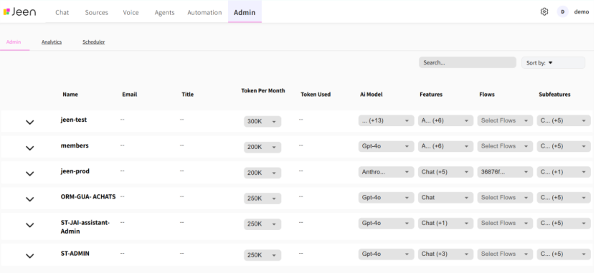

**Main Functions in Admin:**

**Group and User Management**

The main screen displays different user groups. You can set a unique permissions set for each group, and even grant individual users within the group different permissions from the default setting.

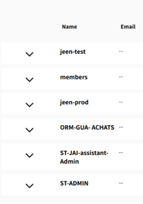

**User Settings**

**Token Per Month**

Through this tab, you can set the number of tokens per user and know the amount of existing allocations.

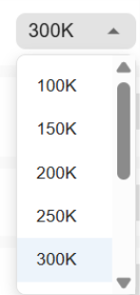

**Token Used**

Through this tab, you can see the amount of tokens that have been used.

תמונה שמכילה טקסט, גופן, לבן, גרפיקה

תוכן בינה מלאכותית גנרטיבית עשוי להיות שגוי.

**AI Model**

Through this tab, you can set which models the user can work with and which will appear to them in the product.

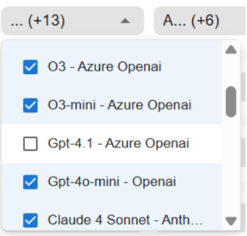

**Features**

Through this tab, you can set which tabs will appear to the user in the product.

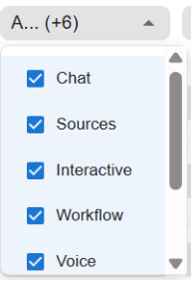

**Subfeatures**

Through this tab, you can set which features will be exposed to the user.

תמונה שמכילה טקסט, צילום מסך, גופן, מספר

תוכן בינה מלאכותית גנרטיבית עשוי להיות שגוי.

**Search and Filtering**

You can search for a specific user/group through the search bar.

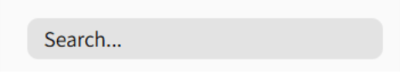

Additionally, you can perform filtering by alphabetical order using this button.

